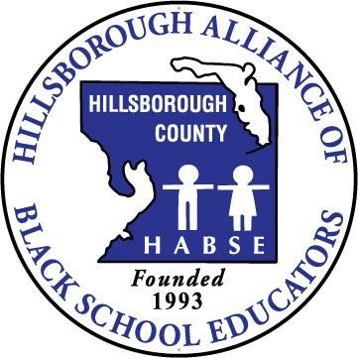

Olympic Parent Summit

In partnership with Full Service Centers, NABSE Parents Commission and

The US Dept. of Education

Wednesday, November 16, 2016 @ Tampa Convention

10:00 a.m. – 1:30 p.m. (Doors opened at 9:30)
Olympic Parent Summit: The summit is to provide awareness of Hillsborough County Public Schools through preventive strategies for parents of youth by providing, parent trainings and engagement opportunities to promote academic success by creating a fun and educational environment. Please note: We have limited space so act fast. Also, please be sure you to receive a Parent Summit ticket and/or a bus pass to complete the registration process.

Parent/Guardian Name: _____________________________________ (Complete one form per adult)
Parent/Guardian Contact Info: Home#/Cell: _________________________________________
Email: ______________________________
Race: White Black Hispanic Other
reate a new Team
reate a new Team
reate a new Team

Olympic Hillsborough County Teams: Please select one

B.T. Washington Clair Mel Cleveland Dunbar Edison Foster Gibsonton Graham
B.T. Washington

James Just Lockhart McLane MS Oak Park Potter Sanchez Sheehy
reate a new Team
West Tampa Wimauma
Create a new Team
OR
(Create a new Team: Write in your school choice) *Please choose only one*
Elementary School _____________ Middle School ________ High School__________________
reate a new Team
reate a new Team
_____________________________________________________________________________________________
Parent Training Survey (Please select your #1 topic to be discussed)
(Topics selected will be based on the highest selections from parents) This component is an adult only event- No child care will be provided.
__“The Olympic Champion of Education” (Circle one or more)  1. Literacy 2. Learning Style  3. Early Learning 4. Absenteeism | __ “The Olympic Champion of Positive Behavior of Children” | __“The Olympic Champion of Effective Communication”
__“The Olympic Champion of Fatherhood and Motherhood” | __ “The Olympic Champion of “Community Safety” | __“The Olympic Champion of Preparing for College and Beyond” (College Access)
__ “The Olympic Champion of Health/Wellness” | __“The Olympic Champion of Family Empowerment” | __“The Olympic Champion of Employment”
__“The Olympic Champion of Blended Family” | __“The Olympic Champion of Managing Your Budget” | __“The Olympic Champion of Special  Education”
- Please check the box if you prefer your break-out session in Spanish
Do you need transportation to and from the Olympic summit? Yes (9:00 a.m. for pick-up) No

Select the pick-up location: Just FSC Sanchez FSC Clair Mel Elem. Gibsonton Elem. Wimauma Elem.
Please inform Full Service Staff if you do not want your picture taken or released
For additional information call Mrs. Conchita L. Canty-Jones, Coordinator of Full Service Centers at (813)-272-0673.

